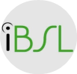
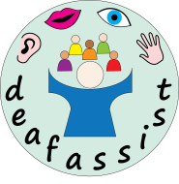

iBSL Level 1 Award in British Sign Language Studies 2019/20

This course is designed to teach you to communicate with Deaf people in British Sign Language (BSL) on a range of topics that involve simple, everyday language use. You will gain basic skills and confidence in producing, and understanding BSL.
Level 1 is divided into three units, each of which can be achieved separately. To achieve the full Level 1 Award in British Sign Language Studies you must pass all three units.
Duration – 25 weeks plus 3 Saturday assessment dates

Day & Time – Thursday’s 6.30-8.30pm (unless otherwise stated)

Venue – Hearing Loss Cornwall, 3 Walsingham Place, Truro, TR1 2RP

Cost & Payment Method – Upfront payment in full - £435.00, or for payment by instalment - £450.00 (both inclusive of assessment fees)
An initial non-refundable deposit of £60.00 is required to secure your place on this course with the balance paid in full 14 days before the course begins. Should you choose to pay for your course by instalment, then an instalment plan will be agreed with the additional £15.00 added to the course fee to administer a payment plan.

Dates 2019/20
Autumn Term
October 3, 17, 31
November 7, 14, 21, 28
December 5, 12, 19

Spring Term
January 9, 16, 23, 30
February 6
March 5, 12, 19, 26, 28

Summer Term
April 16, 23, 30
May 2, 7, 14, 21, 23

3 Saturday assessment dates:
March 28, May 2, May 23

