CORNWALL DEAF COMMUNITY CENTRE
5A East Charles Street
CAMBORNE TR14 8JF

- Cornwall Deaf Community Centre
Chair – Terence Spivey Secretary – Jackie Goldie Vice-Chair (Temp.) & Treasurer – Katherine Thomas
EDITOR: Katherine Thomas -Mobile No: - 07909762233 Email address is kiwier200343@gmail.com
If any news for next Deaf Newsletter issue send me anytime. DEADLINE: December 2019

PATRON’S NEWS

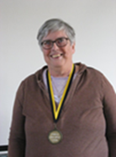
Gosh. Time seems to be flying by. Another newsletter already. It has been a very busy time with collecting at Morrisons again and doing a coffee morning at Chapel Street. I do thank those who helped and supported these events. I also thank all those involved in keeping the luncheon club going, arranging workshops, cleaning the Deaf Centre etc. etc. The workshop on Dementia was brilliant and once again the Deaf showed how much they involve themselves in important subjects. The ladies who took the workshop said it was one of the best groups they had taken, and they hope to come to the Deaf Centre again in the future. One is even encouraged to learn sign language.
We also had our first Deaf Service without Debbie. The hearing preacher Bob Hardman knows some of us from us interpreting Light and Life service once a month. He told everyone how pleased they are to have us with them and said that the sign language takes their service to a better place. It is so beautiful. Of course, we already know that the sign language is wonderful, but it is lovely others are realising it as well.
Reading the August and September Newsletter, there were so many activities that had happened and many planned for November. The Deaf Centre seems to be a really exciting place to be a member of. Hope the planned events go well. Entering a time of storms when writing this so all take care. Until the next newsletter.
Brenda Clarke Patron.

CHAIR’S NEWS
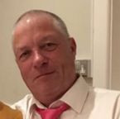
Hi Everyone,
I hope you all had a good holiday in the last few months. Helen and I had a good holiday in London in last weekend of September. We had a few downpours, but this did not stop me taking Helen around part of London that she had never been to.
The Falmouth boat trip last August was a success and many members enjoyed the trip with meals and drinks. Thanks goes to Jackie Goldie for organising this.
We have lot of events planned for the next 3 months so keep your eyes opened for all the events organised. They will be in the newsletter somewhere plus the Cornwall Deaf Community Centre’s website in Facebook and on the notice boards in the Deaf Centre. The committee have been working hard to get all these events organised so well done to the committee.
The Wednesday lunch club every month is still well attended and we were pleased to see 2 familiar faces who had not been to the Deaf Centre for a long time. It was good to see Wendy Harris and Pearl Stoddart coming in and enjoying meeting and chatting with their friends. After lunch, we had 2 young ladies coming to give a talk about dementia which we learned a lot. Thanks to Jackie for organising this and I must not forget to thank Carleen and Jan for interpreting plus we have few more workshops in the next few months.
Deaf cafes are still organised but the last one in St Austell last September was not successful as many of us went to a funeral on the same day. Next one (by the time you are reading this newsletter) will be in Falmouth on Friday 4th October at the Wetherspoon’s pub. I would like to thank Clive Bray for organising this event. The Deaf cafe in November will be on Friday 1st November at the John Francis Bassett pub (Wetherspoon’s) in Camborne from 11.00am. No Deaf Cafe in December as we will all be busy with Christmas shopping. So in January will be in Penzance.
It is with sad notice that Mary May of Camborne passed away peacefully on Wednesday 21st August. Our thoughts go to Mary’s family and to Roger Tonkin (Mary’s younger brother). The funeral was held in Camborne on Friday 6th September and this was very well attended.
Before I forget, time goes backwards on Sunday 27th October at 2.00am so do not forget to set your watches and clocks one hour backwards before you go to bed on Saturday night. This means you will have one-hour extra sleep and it will get darker earlier in the late afternoon/early evening. This means Christmas is coming. So start saving up to buy your loved ones lovely presents.
I do go on and on so I will stop for now but if you wish to have anything put in this newsletter, please either inbox on messenger/Facebook to myself or to Katherine Thomas.
Terence Spivey - Chair

GREAT NEWS FROM HEARING LOSS CORNWALL
The following is an e-mail message from Clare Greenwood, Chief Executive of Hearing Loss Cornwall
You will be delighted and shocked to hear that we have been informed by NHS England Southwest, that our contract to provide BSL services has been extended for one year with the proviso that we will be permitted to bid for any future BSL contract.
In a teleconference with NHS England Southwest, Sharon and Sarah particularly stated that they had listened to us and had realised that they did not understand Deaf issues and needed more time to investigate how to procure services properly! Wow!! The decision was taken on behalf of NHS England Southwest, to extend our contract for another year while they work on improving this procurement process with a better understanding of how Deaf people use the interpreting service to attend appointments. They actually thanked us for being so tenacious on behalf of the Deaf community and providing vital support to inform their process and decision.
I would like to pass on sincere thanks to you all for your support and assistance in getting NHS England to have a change of heart. The charity will now be in a position to provide the ancillary services to the Deaf in Cornwall for another year and will also be allowed to bid next time. We may not win that battle, but we now know that there is a more informed view about deafness and its impact and hopefully that will ensure that Deaf people receive the services they need and deserve in the future.
We are delighted that Deaf people are now on their radar. Let’s hope the NHS continue to remember what they have; learned!
As I have been sharing information with other bodies in the North East and North West, where the procurement process is behind ours, I am hoping that this news will help them to achieve the same outcome.
I hope you had a lovely weekend and we look forward to working with you for at least another year! Business as usual!
Kind regards
Clare
DEMENTIA PRESENTATION
On 11th Sepetmeber, there were over forty attendees attended at Deaf Centre. It was very interesting about the Dementia presentation by Teresa and Claire.
What is Dementia? The brain is made up of nerve cells (neurones) that communicate with each other by sending messages. Dementia damages the nerve cells in the brain so messages can’t be sent from and to the brain effectively, which prevents the body from functioning normally. Regardless of which type of dementia is diagnosed and what part of the brain is affected, each person will experience dementia in their own unique way.
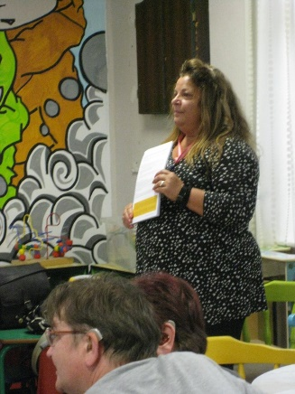
A Dementia Friend is somebody that learns about dementia so they can help their community. Too many people affected by dementia feel that society fails to understand the condition they live with. Dementia Friends help by raising awareness and understanding, so that people living with dementia can continue to live in the way they want.
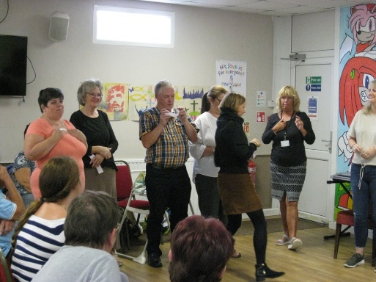
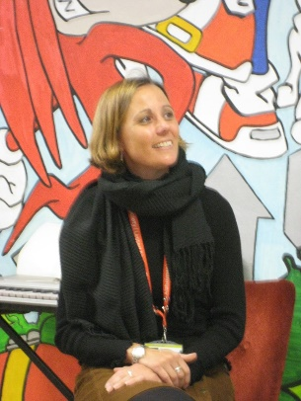

FALMOUTH BOAT TRIP
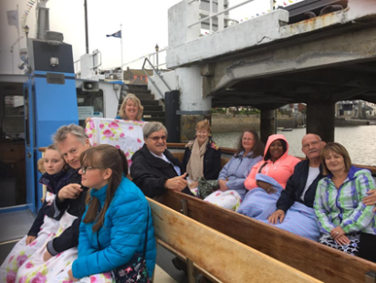
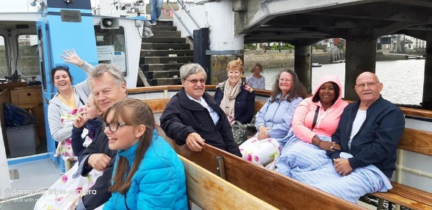
Last August, few members included a couple from Bristol sailed through an area of outstanding natural beauty, this scenic river trip is one of the most beautiful in the world. We enjoyed the trip with fish & chips meals and free Prosecco and soft drinks. Thanks goes to Jackie Goldie for organising this.

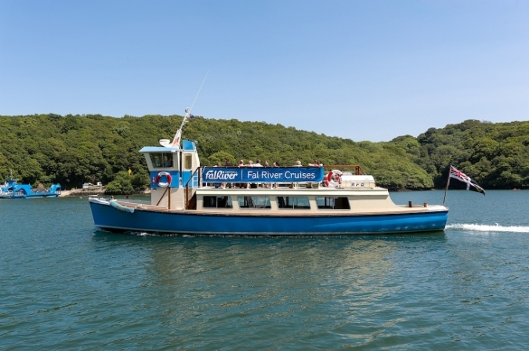

CORNWALL DEAF CHILDREN SOCIETY
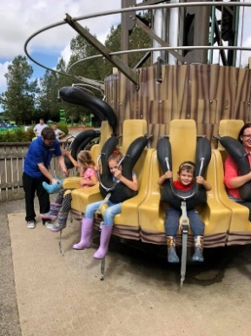
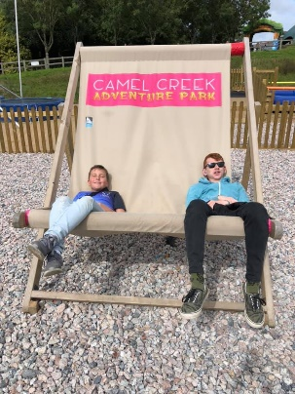
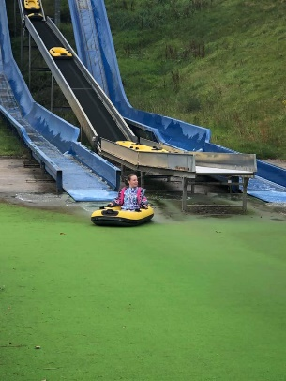
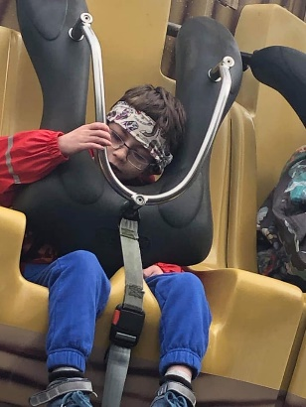

The summer was busy with events for CDCS and although the sun hardly came out, it did not dampen the fun. The family residential at BF Adventure was enjoyed by all and included flying down the zip wire and canoeing in the quarry. We then had two adventure days, one in Tehidy Woods doing bushcraft and the other on Par Beach where they made fires, hot chocolate and explored the beach discovering amazing sea creatures. The summer activities programme ended with a day out at Camel Creek Theme Park and was a perfect end to a wonderful summer for our group.

The group has grown in numbers and we now have members from all over the county. It has been wonderful watching the children meet each other and building new friendships.

Kate is doing a skydive in April next year to raise money for CDCS. This will allow us to continue to support deaf children and their families throughout Cornwall. Please support this by donating through Kate’s fundraising page on the Deaf Centre Facebook group.

Thank you to our amazing committee and especially to our deaf children and their families for making CDCS amazing.

Upcoming Events - all events must be booked

25th October
Halloween Tehidy Adventure Sessions
Fire building, den building, pumpkin carving and much more. Lunch provided.

Sunday, 15th December at 3.30pm - 6pm
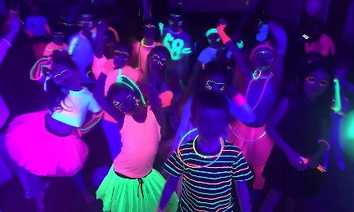
UV Neon Glow Christmas party at Camborne Rugby Club, Camborne.
For deaf children and their families and Deaf adults and their children/grandchildren
Free event but must places must be booked with Kate or Carleen
Kate Ballard-King MPLANT

COCKTAIL AND TAPAS NIGHT
On Sunday 29 September from 6.00 pm to 8.00pm At Chiquito Restaurant, Threemilestone. They have been enjoyable evening. Learn how to make your own Cocktails. The Barmen demonstrates how to make cocktails. Make 3 cocktails of your own choice, two alcoholic cocktails and one non-alcoholic cocktail.
Next booking again in November, you will be able to pick your own ingredients. Included is a choice of Tapas to sit and eat whilst drinking your cocktails. Price £25 per person
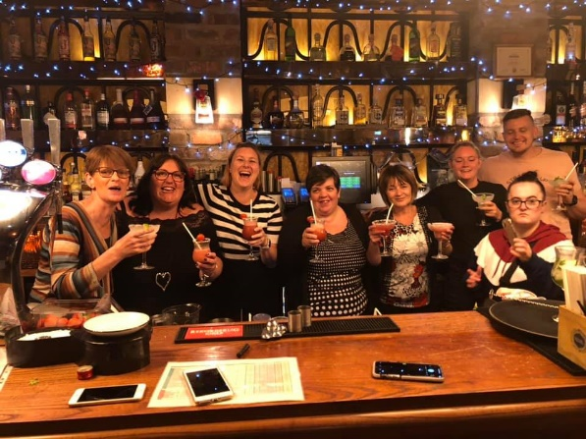
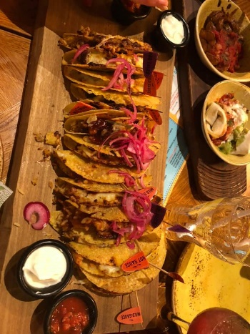
t peace

ASIAN FOOD
On October 11th, Due to unforeseen circumstances we did not do the Racing evening. Because of not many people were there for Racing evening. So have to the Asian food.
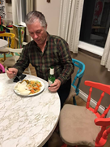
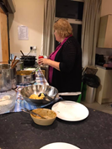
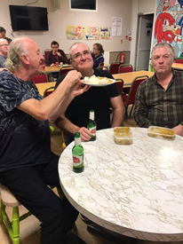
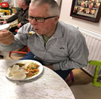

Special thanks to Chanroth for cooking delicious Malaysian foods. Jo and Graham Mace-Butler for helping in the kitchen. Mano Chutney and Benjai Balti for donating all the rice and a few extra bits, China Town for the egg rice, noodles and chips. Raised £100

HALLOWEEN PARTY

On 26th October in the evening, Toby and Jannine Clemence and two daughters organised a fun filled Halloween Party. Jackie made the Halloween food for them.

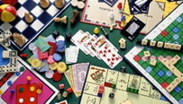
Saturday 2nd November, Torquay Deaf Club will come down to our Deaf Centre for Friendly Indoor Games. Please let Christine Fitzsimmons know if anyone interested to play.

Sunday 1st December 1pm to 5pm – Christmas Craft Workshop. Come along and learn how to make Xmas Rag, Xmas cards & tags, decorate photo frames, decorate a small Christmas cake, candle & table decorations. All materials will be supplied, and you can take your homemade items home. Cost £10 per adult, £5 children aged 3 to 16, free for under 3 years. Price includes a glass of mulled wine/juice snacks. Please let Jackie know if you would like to join this workshop to ensure there are enough craft materials for everybody.
Due to unforeseen circumstances we did not do the Racing tonight. We did have the food.

Congratulations

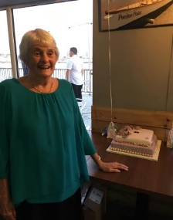
S14thjjjjjjjjjjjjPECIALIST CHLEARLANT

September 14^{th,} Margaret Martin’s 80th surprised Birthday party at Rowing Club Torpoint. Really enjoying her fabulous time with all her families and friends.
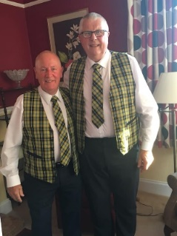

Roger Tonkin and Jeff Palmer are invited for Margaret’s birthday celebration. They wear lovely Cornish waistcoats and ties

On 26th October.
Wishes to say A very happy 70th Birthday to Jane Collins. (Carleen’s mum)
She sometimes helps to sell Tombalo and raffles Deaf Community Centre.
From Deaf Members and friends.

OBITUARY
MARY MAY died on 21st August 2019 aged 89 years old.
Lovely funeral service at Treswithian Downs Crematorium on Friday 6th September 2019 at 1.00pm afterwards Wake at Cornish Chough Pub. Survived her five children. Her younger brother Roger Tonkin

FUNERAL ANNOUNCEMENT
MARGARET GROSE has sadly passed away, aged 87 years. Her funeral will be held on Friday 18th October at 2.00pm at Camborne Church. She had been supported to Deaf Club, etc and generous lady. Sorry no photo.

SAD NEWS
The British Deaf Association is deeply saddened by the recent passing of our previous Chair, Dr. Terry Riley. OBE
A passionate leader and inspirational figure, Terry has had a long association with the BDA spanning over fifty years at different levels; as Branch Secretary, Branch Chairman, Area Council Chair, as a member of the Executive Council, and finally as Chair of the BDA where he served three terms from 2008 – 2018
May he rest in peace.

