CORNWALL DEAF COMMUNITY CENTRE
5A East Charles Street
Camborne Cornwall TR14 8JF
Chair: - Terence Spivey Secretary: - Jackie Goldie Treasurer: - Katherine Thomas
EDITOR : Katherine Thomas -Mobile No:- 07909762233 Email address is kiwier200343@gmail.com If any news for next Deaf Newsletter to send m anytime. DEADLINE: for 31st July 2019

How wonderful it is to have sunshine and longer days of daylight to enjoy ourselves and holidays. I wish everyone good health and a lovely summer. Attending the AGM and the meeting with the NHS, I am so proud of being your Patron. I am grateful to the Committee for all their hard work and we are so lucky to have Jackie Goldie.
Please note that the dates of the collection in Morrisons have changed. They are now confirmed WEDNESDAY 24TH JULY AND WEDNESDAY 4TH SEPTEMBER.
On a personal note I would like to thank Debbie Harvey for everything she has done in the Deaf Club, Deaf Church and as interpreter. We have been truly blessed by having her. We of course wish her a wonderful retirement and future, knowing that the Deaf Community will always be an important part of her life. I am sure we will still see her around and it does not change the very precious friendship we each have with Debbie.
Brenda Clarke Patron.

CHAIR’S REPORT
Hello everyone. This will be my first time doing a report as the new Chairman. First of all, I would like to thank Michael Palmer for all his hard work in the past as our previous Chairman. Also, I would like to thank Jackie Goldie for her hard work as our Secretary and to Katherine Thomas for her hard work as Treasurer. Katherine has a bigger job looking after the money as we received a legacy of some £147,000 left to us in a will. A lot of responsibilities for Katherine. I would to thank the committee members for their hard work too not forgetting the volunteers who helped to keep the club clean and tidy.
The AGM last April went smoothly, and I would like to thank everyone in voting me as the new Chairman. I will be looking to improve the Deaf Centre to the best of my ability.
In the past, we had a successful night at Falmouth Hotel to celebrate our 30th anniversary of our deaf club. Thanks to Katherine and Christine Fitzsimmons for their work in organising this event also to Keith Jones for being the ‘ticket collector’. It was a grand night and I looked forward too many more of this event.
Bridgwater and Taunton Deaf club came to visit us to play our annual indoor games. I was saddened to see we did not have enough players to play for us, so Bridgwater kindly lent us 4 of their players. I am pleased to say we won 14-12 so well done for winning but the most important thing was everyone taking part in good spirit. I must also thank Jackie for her hard work doing the catering and we all enjoyed our meal. Thanks Jackie. Thanks to Christine for organising the games.
The NHS England meeting on 20th May went well too listening to the 4 people from NHS. A lot of questions were asked and answered so now we are waiting to hear the outcome of this in the near future.
Out future events are Racehorse night organised by Mark Cunliffe on Saturday 29th June at the Deaf Centre. Please come along and join in the fun.
Hearing Loss Cornwall will have their AGM on Friday 19th July 10.00am at Cornwall Deaf Community Centre. Please come along and see what HLC are doing for the Deaf in Cornwall.
The committee are organising a day trip to Longleat Wildlife Park on Tuesday 3rd September and there will be a poster on the wall at the Deaf Centre soon for time and price. This is opened to members, non-members and children. A day out for everyone.
Clive Thomas is interested in organising a light walking/rambling day out this year. If you are interested, please let Clive know.
I am interested in organising a ‘Deaf Cafe’ where we can meet at Wetherspoon in Camborne once a month on the first Friday of each month for chat/social/drink/meal from 11.00am onwards. Please let me know if you are interested and this is opened to everyone Terence Spivey – Chair
FRIENDLY INDOOR GAMES
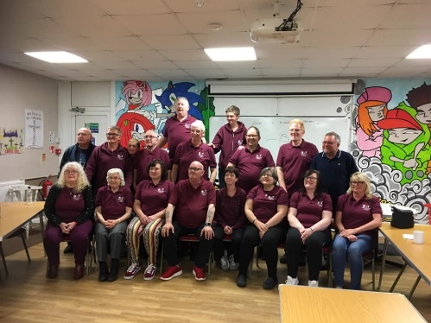
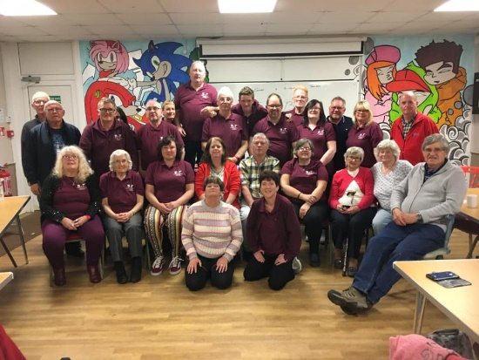
On Saturday 27th April, Cornwall Deaf Community Centre welcomed Bridgwater and Taunton Deaf club to play friendly indoor games. I am proud to say we won 15-13. Well done to CDCC for winning. Also, that to Bridgwater and Taunton Deaf Club for coming over. I must thank Christine Fitzsimmons, Philip Pope and Debbie Elliott for arranging the games. Also, to Jackie Goldie for catering the food. Everyone had a good time. We plan to visit Bridgwater next year so if you are free that weekend, come along and join in the games. TERENCE SPIVEY

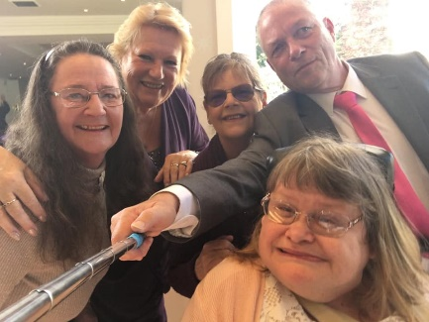
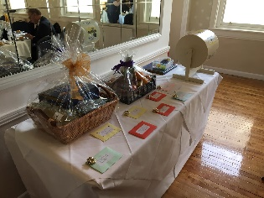
DEAF COMMUNITY CENTRE’S 30TH ANNIVERSARY
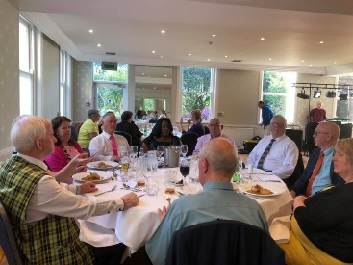
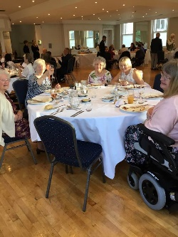

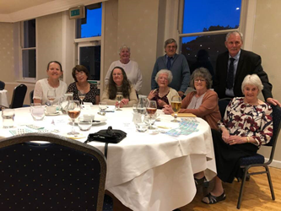
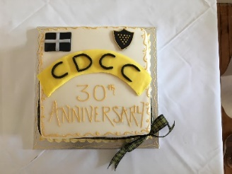

Cornwall Deaf Community Centre’s 30th Anniversary, there were 50 guests enjoyed very minutes of Dinner and dance at Falmouth Hotel. It was brilliant time. Very good raffle prizes – most various vouchers from the Restaurants and two hampers.
CORNWALL DEAF CHILDREN NEWS.
In May, the Lion’s Club for inviting CDCC and CDC’s Deaf children to the fair at Falmouth. They all had a great time during great weather. Lions gave them free icecream and drinks.
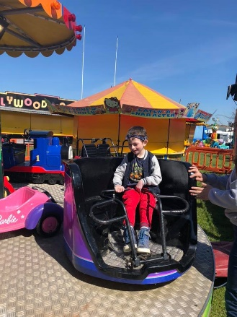
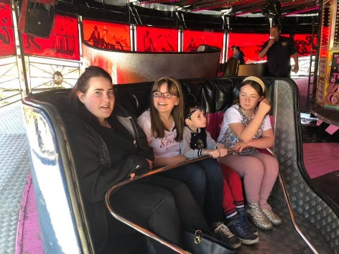

DEAF AWARENESS WEEK
Roadshow helps to boost aims of deaf pupils
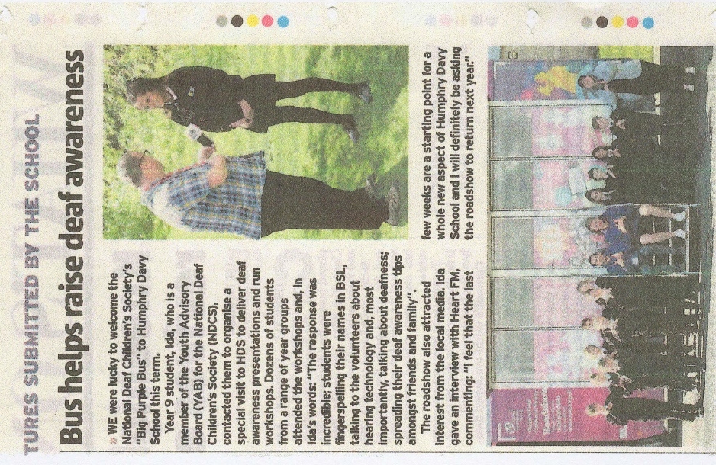
HARD of hearing and deaf PUPILS, In Penzance have shared their experiences with hearing classmates as part of a campaign to raise awareness of what It Is like to be deaf. Organised by the National Deaf Children's Society as part of its nationwide roadshow, the event saw pupils at Humphry Davy School take part in a series of activities. The charity's purple lorry, which turns Into a high-tech classroom visited the school for two days. Staff from the society helped deaf young people to think about their achievements, interests and what they wanted from the future, as well as considering how deafness was an important part of their identity. The society also showcased some of the latest technology and equipment available, ranging from flashing doorbells and vibrating alarm clocks, to an app that helps make phone calls, enabling deaf young people to be more independent. Steven Gardiner, the roadshow's logistics officer, who is deaf himself, said: "We're travelling the country to · help empower deaf young people and raise awareness of deafness among their friends, family and teachers. "When a deaf child is struggling with their confidence, independence or communication, a visit from the roadshow can make a real difference. "Most importantly, we want to remind every deaf young person that they have incredible potential and should be aiming high. With the right support, they can do anything other young people can do.”

NHS ENGLAND
On 20 May at 11am, NHS England – four NHS Speakers visited Deaf Centre and have talked about new plans in the future.
In October 2019 NHS England plan to change how deaf interpreters are booked for your Doctor, Optician and Dentist appointments.
For many years, Hearing Loss Cornwall have booked sign language interpreters for doctor and dentist appointments. This means you have been able to contact Hearing Loss Cornwall (or your preferred interpreter) to make sure you have an interpreter with you when you want one.
From October, NHS England want to STOP using Hearing Loss Cornwall.
NHS England want to use a big national agency to book interpreters.
This could be a big problem for many Deaf people, because you will have to book your own appointments and tell the surgery to contact the new agency and get an interpreter for you. You may not be able to choose which interpreter you want. Wait to hear from NHS England that what did they change the plan for our interpreters from October?
This is from Newcastle as similar as ours.
Why deaf people and other British Sign Language users can struggle to access NHS services
Deaf people and other users of British Sign Language are struggling to access healthcare services, a Newcastle MP has warned.
Catherine McKinnell, Labour MP for Newcastle North, demanded better access to treatment and information for users of British Sign Language (BSL), as she led a Parliamentary debate.
It came after constituents and local deaf organisations, including Deaflink North East, warned BSL users still face difficulties trying to make use of everyday public services because their communication needs simply aren’t being met.
Ms McKinnell raised examples of deaf people having to rely on family and friends in order to make medical appointments, because they have to be made over the phone. She told the Health Minister about BSL users being provided with a telephone number in order to book a BSL interpreter to help at an appointment, even though they cannot use a phone.
Patients also find that interpreters are not fully qualified, or the appointment is too short for BSL interpretation to take place. already in place in Scotland.
- She said: “I would like to ask the minister whether she really thinks it is appropriate to expect adult BSL users to have to continually rely on family and friends – and often their parents – in order to access healthcare and treatment, or discuss private medical information? MPs to investigate reality shows Jeremy Kyle and Love Island following tragic deaths
“This is not a situation that any one of us would tolerate, so why on earth should deaf people have to do so in 2019 – almost a decade after the Equality Act became law?”
Speaking after the debate – which featured live BSL interpretation as well as online simultaneous translation and subtitling – the MP said: “Whilst the minister appeared to take on board the concerns I and other colleagues raised this afternoon, we need to see concrete action on this issue not more warm words.
“I remain unconvinced the existing legislation is sufficient, and the Government needs to think very carefully about how it protects and promotes the rights of BSL users – as the recognised language of the British deaf community given the seriousness of the concerns I raised today.”
The debate took place followed Deaf Awareness Week, which took place from May 6 to 12.
Denis Richards’s message.
LANZAROTE

Hi. Hope you're all well! I have been speaking with my bosses and they have agreed that anyone whom is Deaf of Hard of Hearing or a member of any of the Deaf Clubs or Centres can receive a special discount if they book a villa or suite holiday with us. I'm also on hand to interpret if needed. I need to get this information out. Do you have any ideas who I can send it to please? It would also be good to see anyone that does come out to catch up.
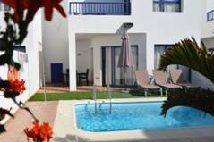
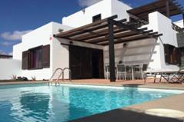

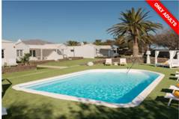
Villas Puerto Rubicon Villas El Partidor

Villas Lanzasuites
I was wondering if you would like to share this with the committee and members of the Camborne Deaf Community Centre and any other Deaf Clubs, you have connections with.
I work as receptionist for two complexes of villas and suites.
We are pleased to offer you our wonderful family friendly villas in Playa Blanca, Lanzarote, as our location is unbeatable next to the Marina Rubicon.
Villas Puerto Rubicon are fully equipped for the enjoyment of a comfortable and relaxed stay, with private swimming pool, garden, barbecue and free parking.
They consist of 2 or 3 bedrooms with a spacious and bright living room with dining area, separate kitchen, 2 or 3 bathrooms and terrace.
Free WI-FI and cleaning service for minimum stays of 7 days, a change of sheets and towels included free of charge.
Website for more information: www.villaspuertorubicon.com
Lanzasuites is a luxury complex of Suites in Playa Blanca, Lanzarote called Lanzasuites. It is an “adults only” complex, no one under the age of 18 allowed.
These are one-bedroom Suites with Satellite T.V. in the lounge and independent Satellite TV in the bedroom. Fully equipped kitchen. Shower room with walk-in shower. Private terrace with barbeque, sun loungers, table and chairs for outside dining.
There is a communal, saltwater plunge pool, and many Balinese day beds for you to relax in. Secure gated access means it is a very secure area for a totally relaxed holiday.
Within 5 minutes, the nearest beach, supermarket, the Centre of town with a large selection of restaurants and the ferry crossing point to Fuerteventura, if you would like a daytrip to explore a different island during our stay.
If you do not have a car, excursions can be arranged to visit the majority of the island, either in one day or half-days to visit the parts of the island that Lanzarote is famous for.
Website for more information: www.lansuites.com
It is important to mention my name: Denis, and which Deaf Club or Deaf Centre you are from when booking to receive the best discount. I am also on hand to translate if necessary.
You can contact me by email if you have any questions on:
booking@villaspuertorubicon.com
or text message or WhatsApp on 0034 676 031 864 9am to 5pm only.

WHAT’S ON
Horse Racing and Curry Night
on Saturday 29th June.
6.00pm – Eating
7.15pm – Races start.
£5.00 entry – including choice of curry with poppadum/naan.
£2.00 entry without eating.
Alcohol & soft drinks tombola and Raffle prizes.

Collecting tins at Penzance Morrisons on Wednesday 24th July and Wednesday 4th September from 10.00 am to 4.00pm

Tuesday 3rd September – Outing trip to Longleat Safari park by coach. Please let the committee members now than too late. Welcome everyone – Members and non-members, Families with Deaf children and grandchildren. More details later.

Saturday 21st September 10 am to 12 noon is our coffee morning for Cornwall Deaf Community Centre.

DEAF 4 DEAF
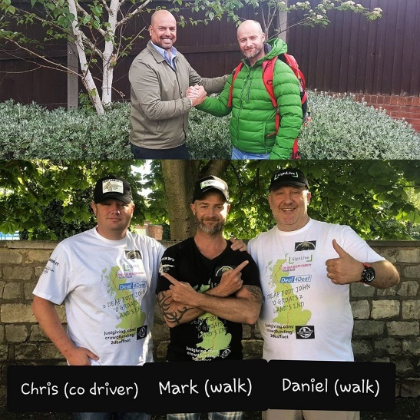
On 5th June two Deaf Walkers are walking from John O’ Groats Scotland to Land’s End Cornwall for a great cause, raising money and creating awareness for Deaf Mental Health Organisations. A cause to our hearts. Will reach at Land’s End on Saturday 10th August if possible.
They are raising £10,000.00 to support Deaf Mental Health – https://www.justgiving.com/crowdfunding/2deafootwalk

OLD FRIENDS
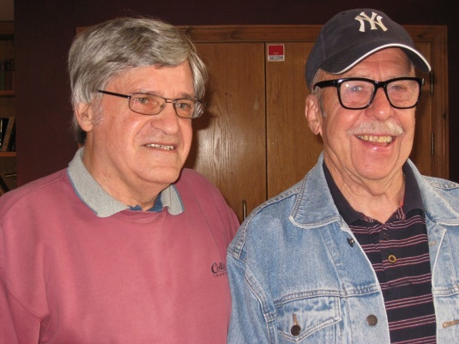
Clive Thomas met Adrian Willrich at Truro Wetherspoon and never seen him in the last 42 years ago when they had been travelling to Europe by coach with Deaf tourists and visited Sweden for Deaf World Games in 1973 and was farewell Clive before went to OZ.

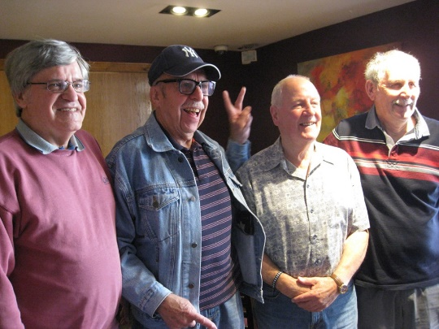

Yesterday Terry Martin and Roger Tonkin met Adrian Willrich too. They all were attending Stoke School for the Deaf. We have lovely catch-up chat for few hours in Truro Wetherspoons.

